CS 4700 Prelim 1 Prep Questions

1. True/False
   1. True
   2. False
   3. False
   4. True (but only with an admissible heuristic)
   5. True
   6. False (I’m not really sure what it’s asking?)
2. Question Two

|  |  |  |
| --- | --- | --- |
|  | a | b |
| Can use time exponential in m | Can use space exponential in m |
| DFS | $O\left(b^{m}\right)$**X** | $$O(bm)$$ |
| BFS | $O\left(b^{d}\right)$**X** | $O\left(b^{d}\right)$**X** |
| Best-first search | $O\left(b^{d}\right)$**X** | $O(b^{d})$**X** |
| Hill climbing search | $$O\left(bm\right)$$ | $$O(b)$$ |
| A* search | **X** | **X** |

* 1. That ^
  2. That ^
  3. Yes. Refer to my handwritten work. But a verbal explanation is A* can have a really good heuristic and quickly reach the goal while DFS goals to all these useless nodes first before reaching the goal.

1. No: it may be infinite! There might be no global minimum if the function is concave.
   1. Shit that was wrong. The answer is yes because $0<f\left(s\right)≤100 ∀ states s$. Hill climbing only moves when there’s a *strictly* better state. The maximum number of moves is 100.
2. Graph traversal
   1. S, A, D, C, G1
   2. S, A, B, D, E, C, G1 (oops this was BFS; I really gotta check myself before I wreck myself)
      1. Iterative deepening:
         1. S
         2. S, A, B
         3. S, A, D, B, E
         4. S, A, D, C, G1
   3. S (that’s it, it gets stuck because its neighbors have the same f(s))
      1. Oh nah: there’s a **tie-breaking** rule (earlier in alphabet). But actually it should get stuck in local optimum at D Second attempt: S, A, D, G2
   4. S, A, D, B, G2
   5. Yes! It never overestimates the cost of getting to either of the goals for ANY node. I believe I don’t have to write the actual cost for all the nodes to reach the goals right…?
3. Minimax
   1. -3 (root), -3, -6, -9
      1. Oh fk myself maximizer; opponent is minimizer. Whoever’s turn it is DETERMINES THE ROOT Second attempt:
         1. -2 (root), 7, -2, 8
   2. The middle branch.
   3. 8, -9
4. Yes. There could be no pruning available so they’ll end up the same.
5. Drawn on paper
   1. 3
   2. 5
   3. -2
   4. Left leaf -2
   5. Right-most leaf 8
6. The reward could be the current state’s or the next state’s. The exam will specify.

$$U^{*}\left(<1,1>\right)=0.8\left(-0.04+0.7U^{*}\left(<1,2>\right)\right)+2*0.1\left(-1+0.7U^{*}\left(<2,1>\right)\right)$$

$$U^{*}\left(<1,2>\right)=0.8\left(1+0.7U^{*}\left(<2,2>\right)\right)+2*0.1(-0.04+0.7U^{*}(<1,1>))$$

$$U^{*}\left(<2,1>\right)=0.8\left(1+0.7U^{*}\left(<2,2>\right)\right)+2*0.1(-0.04+0.7U^{*}(<1,1>))$$

$$U^{*}\left(<2,2>\right)=0.8\left(-0.04+0.7U^{*}\left(<1,2>\right)\right)+2*0.1(-1+0.7U^{*}(<2,1>))$$

$A=U^{*}\left(<1,1>\right)$

$B=U^{*}\left(<1,2>\right)$

$C=U^{*}\left(<2,1>\right)$

$D=U^{*}\left(<2,2>\right)$

$A= -0.032+0.56B-0.2+0.14C=-0.232+0.56B+0.14C$

$B=0.8+0.56D-0.008+0.14A=0.792+0.56D+0.14A$

$C=0.8+0.56D-0.008+0.14A=0.792+0.56D+0.14A$

$D=-0.032+0.56B-0.2+0.14C=-0.232+0.56B+0.14C$

$U^{*}\left(<1,1>\right)=U^{*}\left(<2,2>\right)=0.632$

$U^{*}\left(<1,2>\right)=U^{*}\left(<2,1>\right)=1.234$

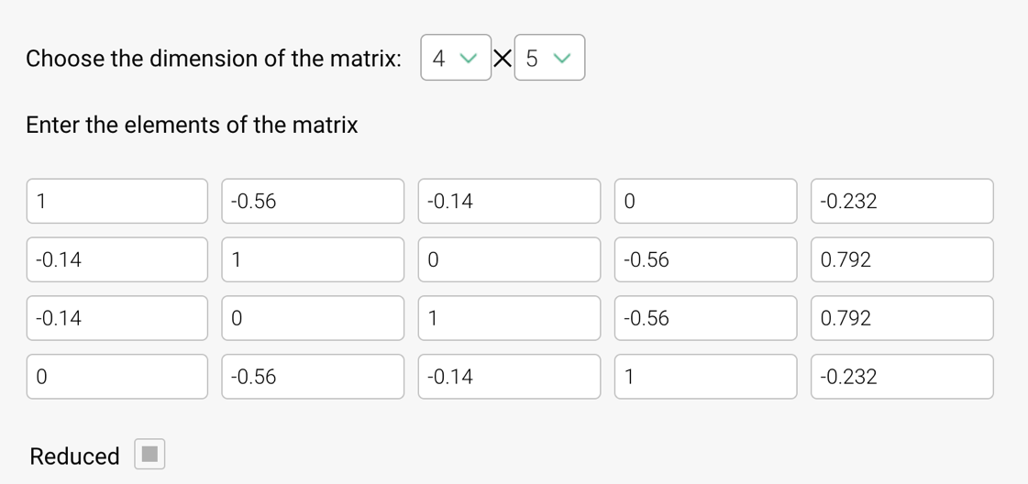

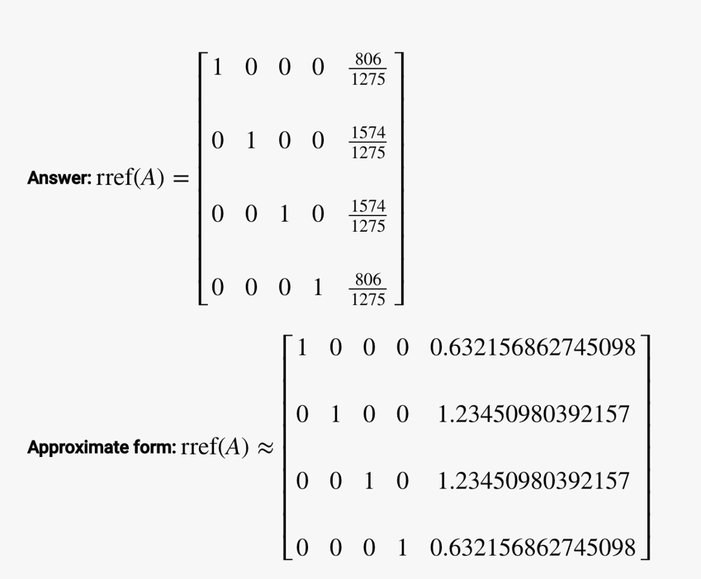

1. More MDP

* 1. (if N is odd)

* 1. If is odd then move to 1. Stay in $N$ otherwise. Same policy as proposed in c. $U^{π*}\left(N\right)=2$
  2. Not in scope of exam.